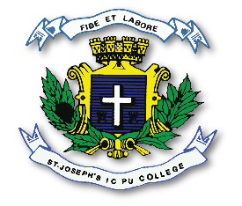
ST. JOSEPH’S INDIAN COMPOSITE PU COLLEGE
#23, Vittal Mallya Road, Bangalore – 560001.

SUBJECT: ELECTRONICS (40)
PORTIONS FOR I TEST – 2023-24

Chapters - 1. Introduction to Electronics
2. Principles of Electricity, Network Theorems and AC principles.
4A. Passive Electronics Components Resistors.

